5 Hour 30 Minutes
I had issues with figuring out what the assignment wanted and what the limits were. (Not much was clear for me) It also required me to use something from the next chapter in the Python crash course.

Code1.py
Import myimport
myimport.main()
Output:
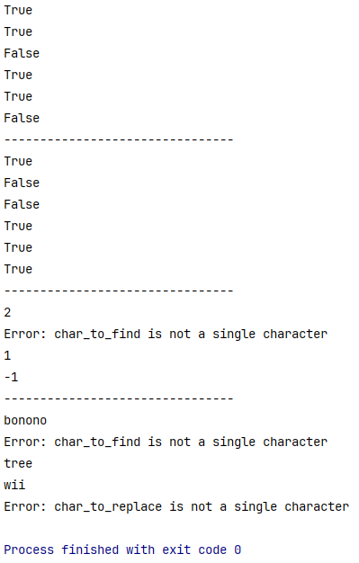

import myimport
print(myimport.is_digit('17'))
print(myimport.is_digit('ab'))
print(myimport.is_alpha('12'))
print(myimport.is_alpha('aB'))
print(myimport.find_chr('cinnamon', 'n'))
print(myimport.replace_chr('accebborieb', 'b', 's'))

Output:
